Hack #1: Comparison of The Hunger Games’ “Hanging Tree” as sung by Jennifer Lawrence and Billie Holiday’s “Strange Fruit”. Where Holiday’s song is a somber and emotional portrayal of the all to frequent and prejudice lynching of black Americans at the time of its transcription (1937), Lawrence’s song portrays a love affair between a murderer hung for his crimes and his lover. I hear an eerie resemblance.
~~~~~~~~~~~~~~~~~~~~~~~

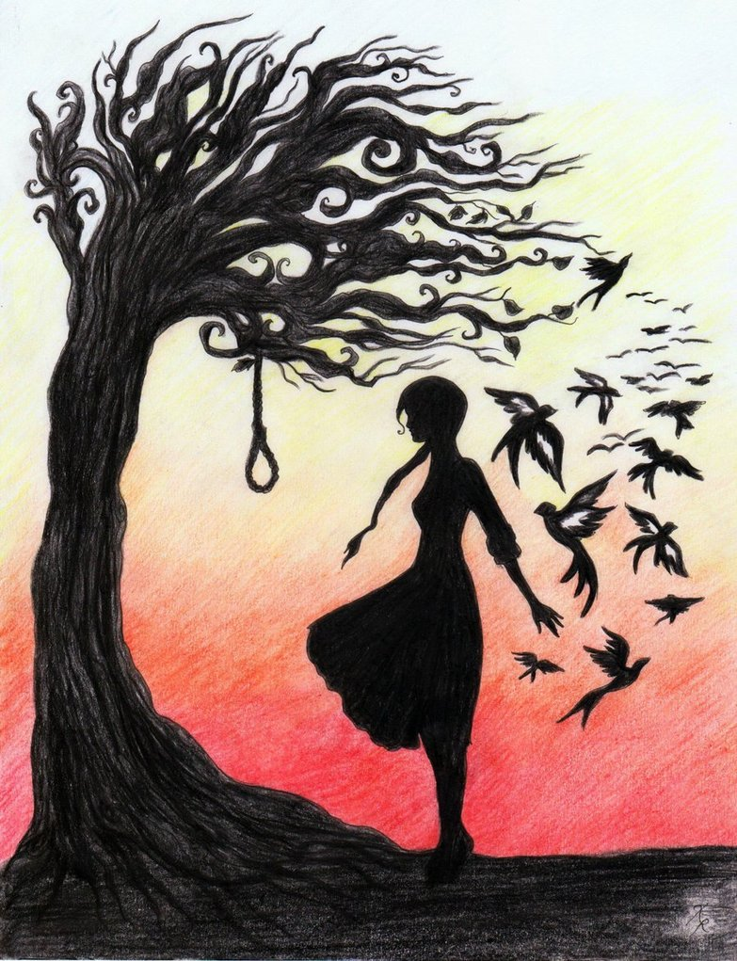
Are you, are you
Coming to the tree
They strung up a man
They say who murdered three.
Strange things did happen here
No stranger would it be
If we met at midnight
In the hanging tree.

Are you, are you
Coming to the tree
Wear a necklace of rope,
Side by side with me.
Strange things did happen here
No stranger would it be
If we met at midnight
In the hanging tree.
-Jennifer Lawrence

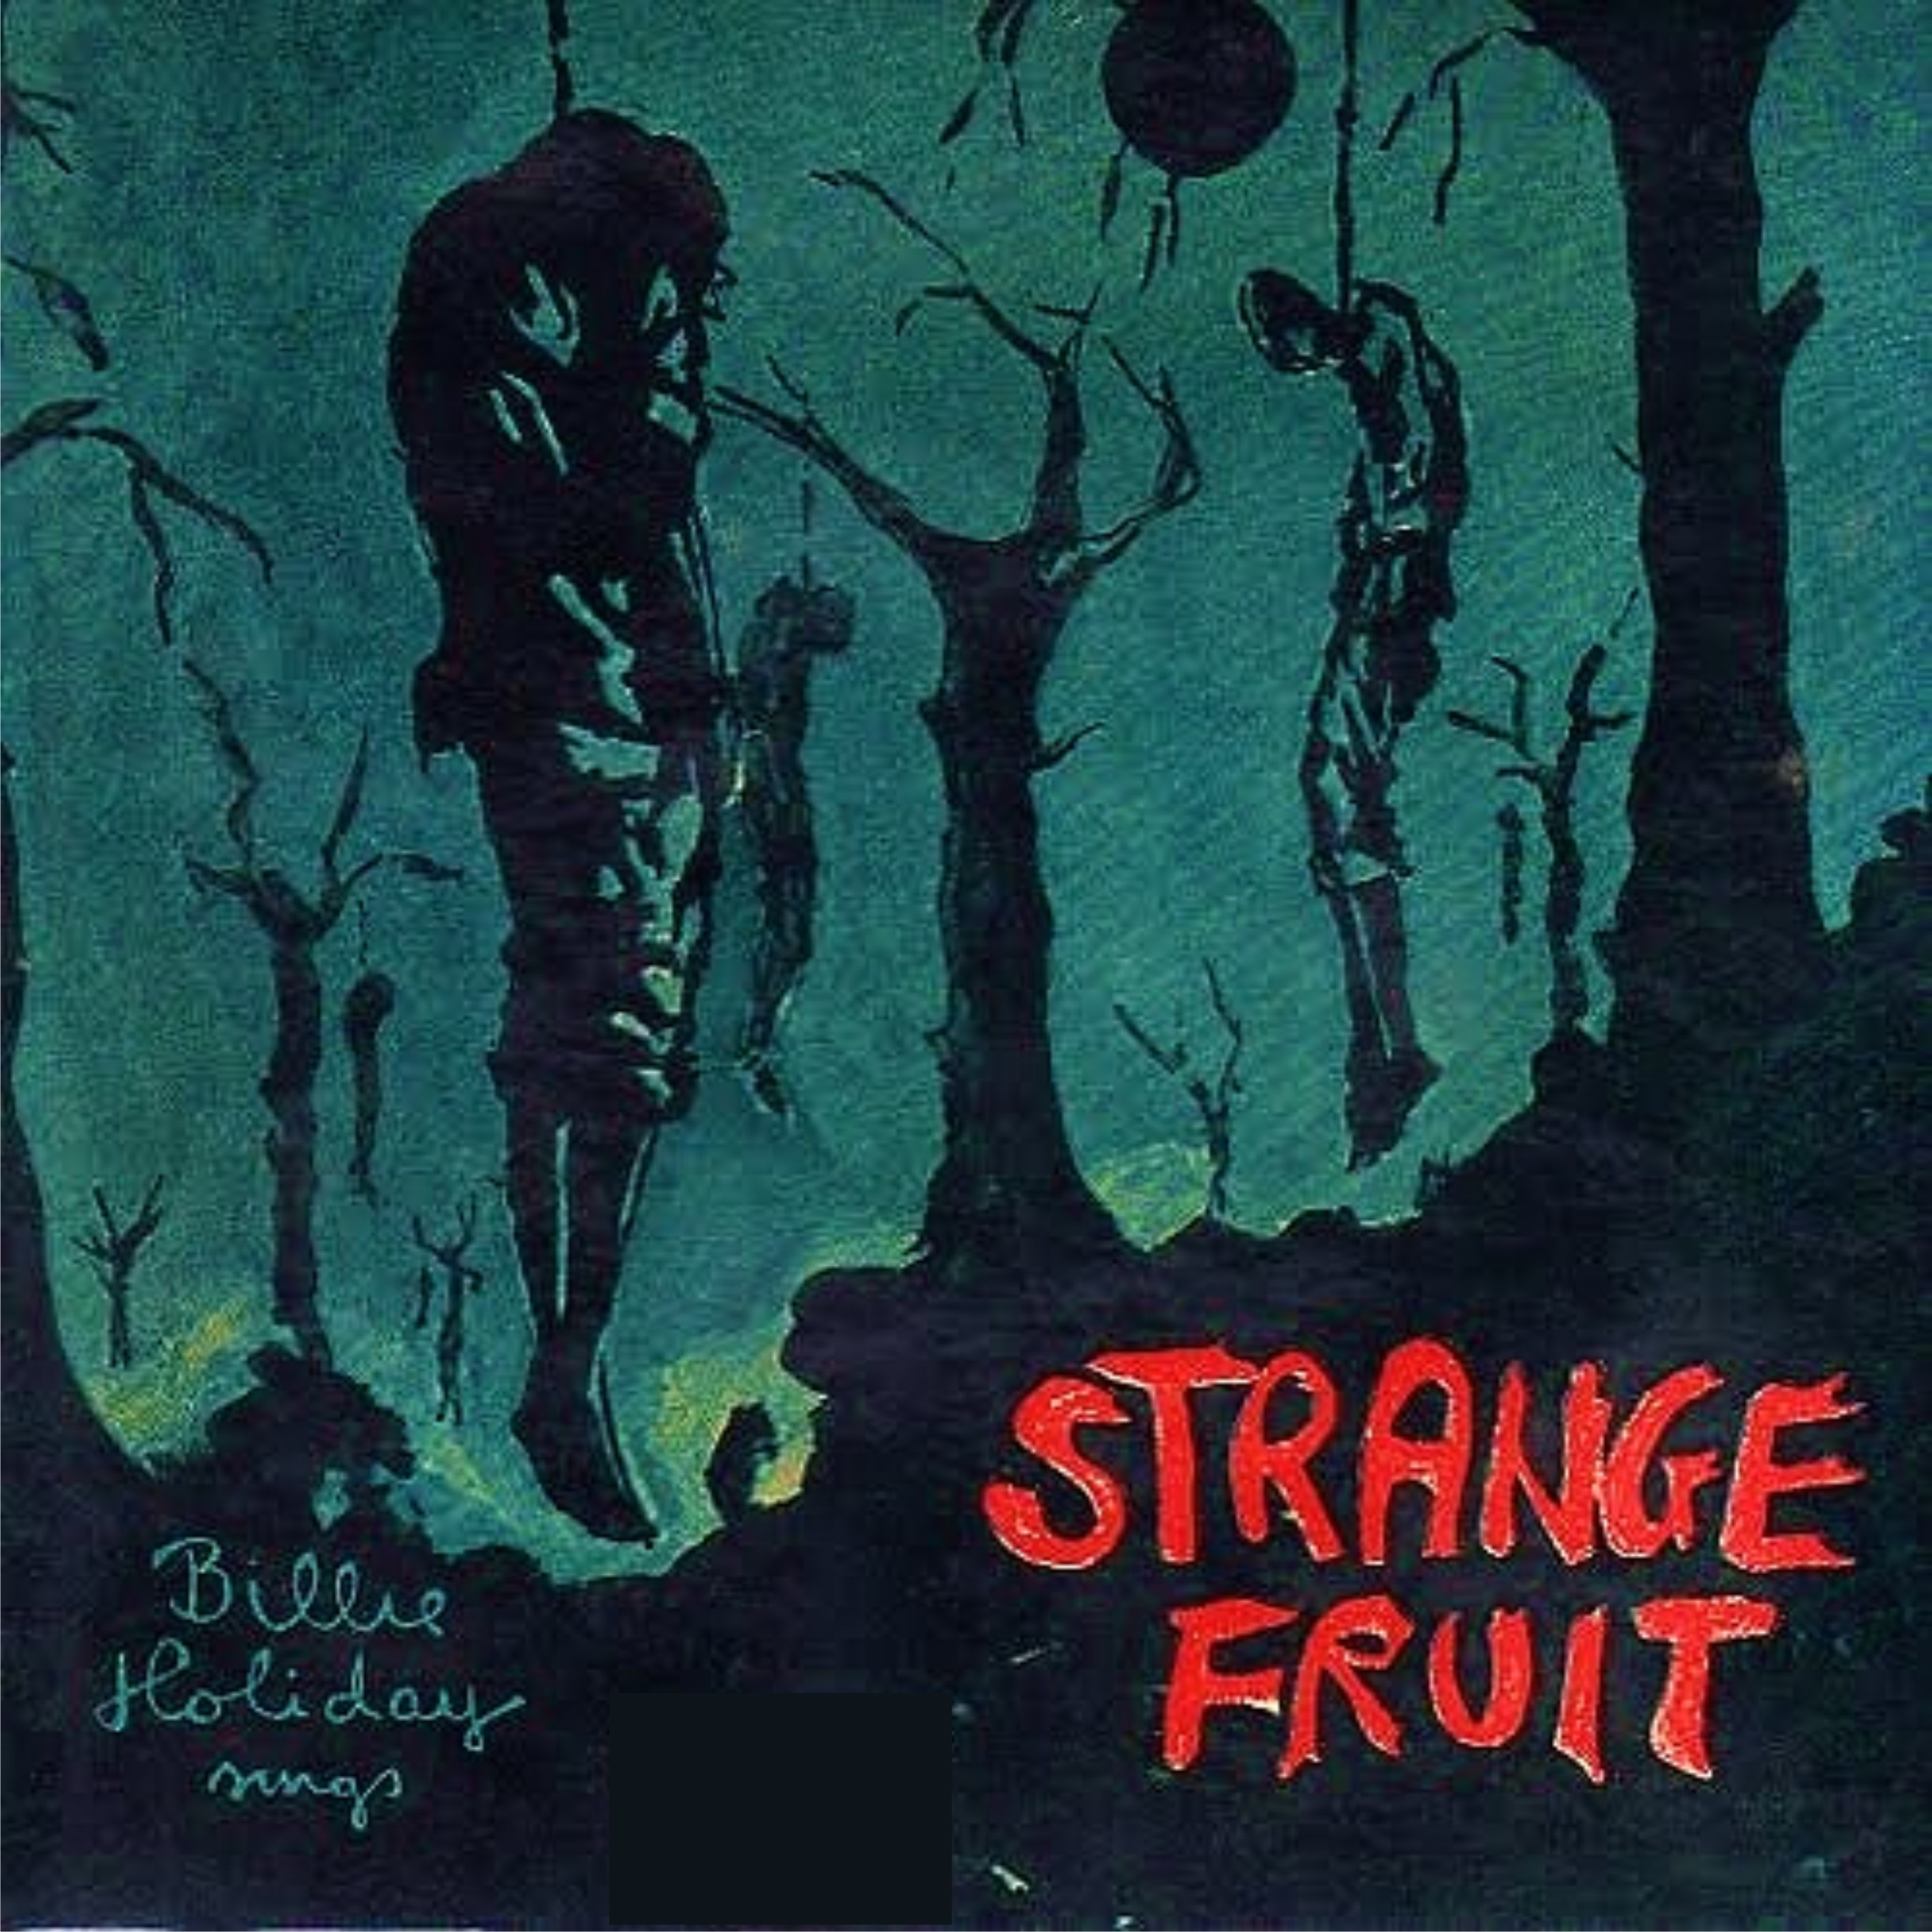

Southern trees bear a strange fruit
Blood on the leaves and blood at the root
Black bodies swingin' in the Southern breeze
Strange fruit hangin' from the poplar trees
Pastoral scene of the gallant South
The bulgin' eyes and the twisted mouth
Scent of magnolias sweet and fresh
Then the sudden smell of burnin' flesh
-Billie Holiday

